MEET THE SPINE FACULTY
University of Maryland board-certified and fellowship –trained orthopaedic spine surgeon

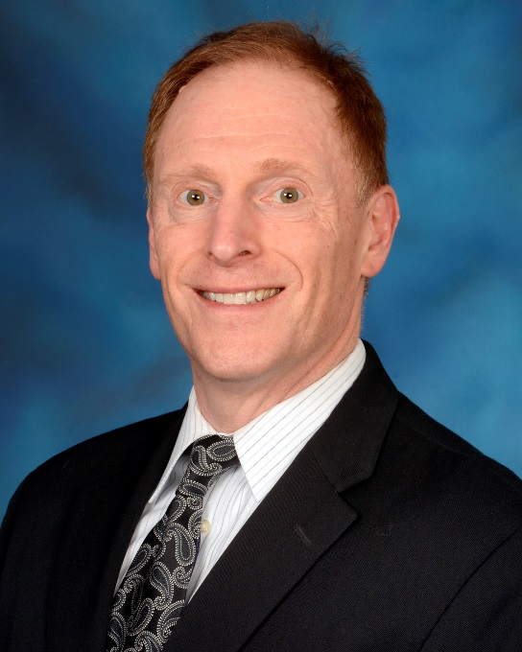
DANIEL GELB, MD
Associate Professor of Orthopaedic Surgery
University of Maryland School of Medicine

Vice-Chairman
Department of Orthopaedics

Phone: 410-328-3700
Fax: 410-328-0534

Mailing Address:
University of Maryland Orthopaedic & Spine Center
110 S. Paca Street
Floor 6, Suite 300
Baltimore, MD 21201

Since 2002, Dr. Gelb has been treating patients at the University of Maryland. His clinical interests include pediatrics, adolescent, and adult spinal deformity including scoliosis and kyphosis, spine trauma, spinal surgery for metastatic disease and chronic infections of the spine; additionally, he treats disc herniation, spinal stenosis and spondylolisthesis. Dr. Gelb graduated summa cum laude and Phi Beta Kappa from Dartmouth College in 1983 and then received his medical degree from the New York University School of Medicine, where he was elected to the Alpha Omega Alpha Medical Honor Society. Dr. Gelb continued his training with a residency in orthopaedic surgery at the University of Rochester. He completed his fellowship in spinal surgery at Washington University in St. Louis and then received advanced training with a Cotrel fellowship in scoliosis surgery in France. Dr. Gelb has an interest in resident education and has twice been awarded “Teacher of the Year” in the Department of Orthopaedics. He is a member of the Scoliosis Research Society, North American Spine Society, American Academy of Orthopaedic Surgeons, and AOSpine.

