MEET THE SPINE FACULTY
University of Maryland board-certified and fellowship –trained orthopaedic spine surgeon

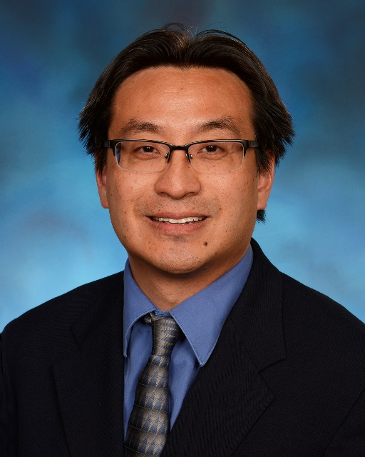
EUGENE KOH, MD, PHD

Assistant Professor of Orthopaedic Surgery

University of Maryland School of Medicine

Chief of Orthopaedics

Baltimore VA Medical Center

Phone: 410-328-3700

Fax: 410-328-0534

Mailing Address:
University of Maryland Orthopaedic & Spine Center
110 S. Paca Street
Floor 6, Suite 300
Baltimore, MD 21201

Dr. Koh serves as the dedicated spine surgeon and the Chief of Orthopaedics for the Baltimore VA Medical Center. Under the Medical Scientist Training Program, he received a dual degree of MD-PhD from the Harvard School of Medicine and the Massachusetts Institute of Technology. He completed an orthopaedic surgery residency at Rhode Island Hospital, and affiliate of Brown University, and went on to complete two fellowships at Rhode Island Hospital and Emory University in orthopaedic trauma and orthopaedic spine. Dr. Koh graduated summa cum laude and Phi Beta Kappa from Harvard. Dr. Koh has authored over two dozen journal articles and has been invited to speak at numerous conferences. He is an active member of the American Academy of Orthopaedic Surgeon and the Society for Minimally Invasive Spine Surgery. Dr. Koh’s specific area of interest and clinical expertise, include disorders of the cervical and lumbar spine, minimally invasive spinal techniques, and reconstruction of the traumatically injured spine.

