UMMC DTC Offsite Health Evaluation Color Vision Screen Form page 1
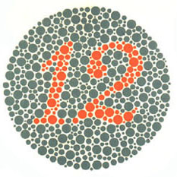 | 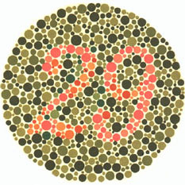
Plate #1 Number seen = | Plate #4 Number seen =
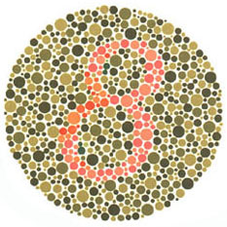 | 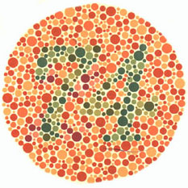
Plate #2 Number seen = | Plate #5 Number seen =
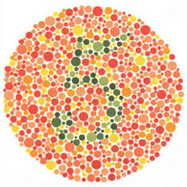 | 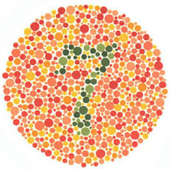
Plate #3 Number seen = | Plate #6 Number seen =

Employee Name:_______________________________________________ Date:_______________

UMMC DTC Offsite Health Evaluation Color Vision Screen Form page 2
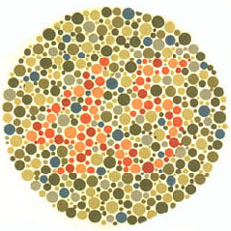 | 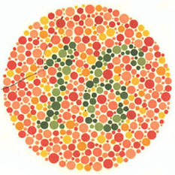
Plate #7 Number seen = | Plate #10 Number seen =
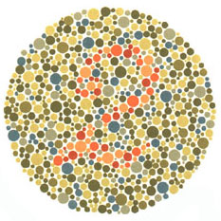 | 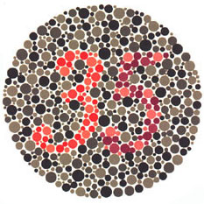
Plate #8 Number seen = | Plate #11 Number seen =
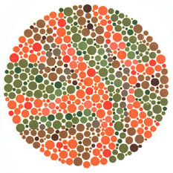 | 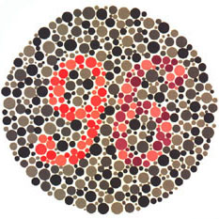
Plate #9 Number seen = | Plate #12 Number seen =

Employee Name:_______________________________________________ Date:_______________
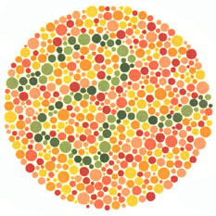

Plate #13 Please trace the green line with a pen.

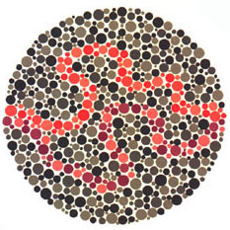

Plate #14 Please trace the red line AND the purple line with a pen.

Employee Name:_______________________________________________ Date:_______________

