**Instructions for Dynamic On-boarding PDF**

**IMPORTANT! Before you begin, please read these instructions carefully…**

**You do NOT need to complete any additional information after page 7 (has a red NOT VALID box) of the onboarding packet. The onboarding packet will “self-populate” required fields of the onboarding** **documents as you complete the first seven pages of the packet. Do NOT change any information on the forms after the validation page. Do NOT alter the onboarding packet fields or information (other than** **what you entering).**

**The onboarding packet requires sensitive information. Please ensure that you take the appropriate precautions to safeguard your information (e.g. public computer, non-encrypted or password protected** **computer, etc.)**

**Your program title is Nurse Anesthesia /affiliate number is 68.**

It is recommended that you complete your onboarding packet on a PC (not a Mac). To complete the onboarding packet, you must use “**Adobe Reader” ONLY**. You may download the reader from the internet ([get.adobe.com/reader](https://get.adobe.com/reader/)). It is recommended that you pay careful attention to the installation instructions **and opt-out of any optional offers** unless you wish to add those features to your computer, etc. Do not select “Install the Acrobat Reader Chrome Extension (uncheck the box). Always read the Terms & Conditions.

1) **SAVE** the onboarding packet to your computer first.

2) Then, open the onboarding packet using Adobe Reader. On the second page of the onboarding packet you will see a blue button with the word “**Show**”. Click on the blue button to reveal all of the required fields.

3) Complete all required fields (in red). Optional fields (as indicated by a blue/gray box) are completed as required by your individual responses.

4) **SAVE and close** the document. REOPEN the document with Adobe Reader. Verify that the box on page 7 has changed to indicate the onboarding packet is now “VALID”. A VALID status is indicated by the box color changing to green and by the word VALID appearing. Do not submit an onboarding packet that is not VALID.

5) **PRINT** the onboarding packet and **SIGN (NO Digital Signatures)** all fields indicated by a blue star. Scan the signed forms and save to your computer. Submit a copy of the signed onboarding packet AND a copy of the electronic onboarding packet *(in the original fillable PDF format)*. **No pictures or images of the documents will be accepted**. Scanned pdfs only. **Instructions on how to send your forms in are shown below.

**Onboarding will not begin until all documentation is received in the required formats. Delayed submission of your onboarding documents will impact your ability to begin your clinical rotation.

6) Additional requirements to be submitted with the onboarding packet: *only submit these if they apply

♣ Naturalized US Citizens: submit documentation to support your status (e.g. copy of naturalization certificate or US passport)

♣ Non-US Citizens: submit documentation showing your current status.

**You will need to complete your fingerprints with Human Resource immediately after submitting your package; to avoid holding up any processes. Print page 20 and hand carry to HR to get fingerprints. Please ensure you take two (2) valid forms of ID.**

**HR Hours of Operation (Closed on Holidays) are: Monday-Friday, 8 a.m. – 3:00pm.**

Human Resources is located at the Baltimore VA Medical Center, which is located at 10 N. Greene Street, Baltimore, MD 21201. Human Resources Personnel Security is located on the 6th floor. You may enter the facility through the front lobby or through the University/VA skywalk from the 3d floor of the University of Maryland’s main hospital. If entering through the front door take the escalator to the second floor and take the elevators to the 6th floor. When exiting the elevators turn right exiting through the double doors to the right and take the first hall on the left. Human Resources Personnel Security is at the end of the short hall. From the skyway you will take the elevators directly across from Starbucks and follow the directions above. Call HR at 410-605-XXXX if you need assistance.

**Parking**

There is no parking available at the Baltimore VA Medical Center. There are several local parking garages in the area and there is limited street parking available on Fayette Street.

**To return your onboarding packet to the __________@va.gov. You may:**

**-Email it**

* **email us to let us know you are ready to send in your packet; and we will send you a secure link.**
* **Below is what you will see with the secure link.**

**WE WILL NEED TO FIGURE OUT HOW TO DO THIS**

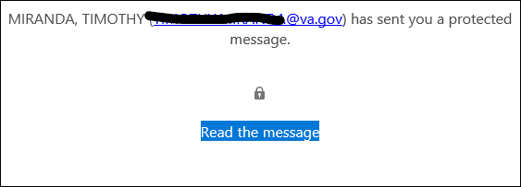

After clicking the button, the user is sent a code like TMS.

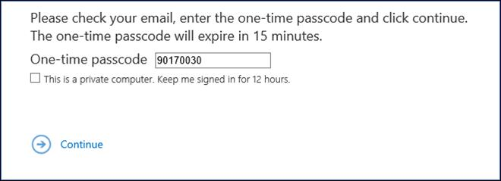

After entering the code then they can view the secure message

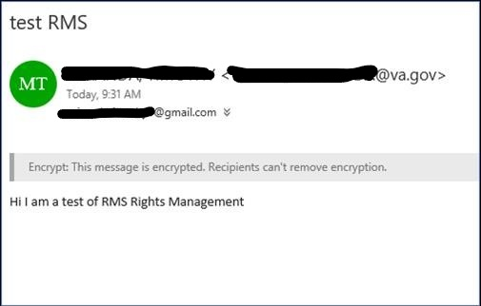

And they can hit reply and attach any needed documents.

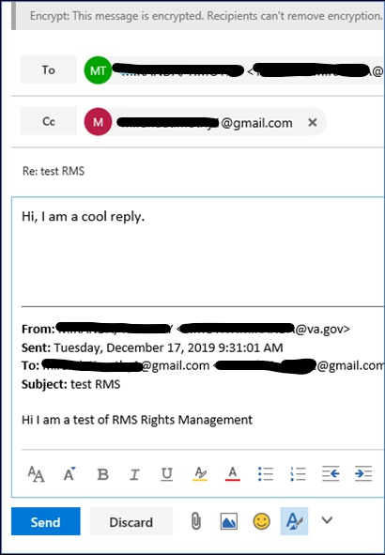

**-Email it**

* **email us to let us know you are ready to send in your packet; and we will send you a secure link.**